Certificate of Compliance Build America, Buy America Act
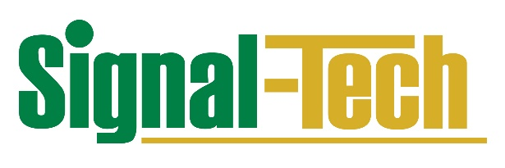

July 2024
To our valued partner,
This letter certifies that the Signal-Tech transportation industry products listed below meet the Build America, Buy America (BABA) Act requirements. Signal-Tech uses domestically sourced and produced materials and components where economically feasible and available. These products are designed, engineered, assembled, and tested in the U.S. at our Erie, PA facility. The cost of the components of these manufactured products is greater than 55 percent of the total cost of all manufactured product components.

Product Type
DOT – LED Blank-Out Signs for Traffic Applications
STR – Direct-View, Blank-Out, Single-Faced LED Signs for Traffic & Outdoor Applications
STRB – Backlit, Blank-Out, Single-Faced LED Signs for Traffic & Outdoor Applications
STRI – Backlit, Always-Illuminated, Single-Faced LED Signs for Traffic & Outdoor Applications
Internally Illuminated Street Name Signs
Mounting Brackets

Signal-Tech is proud to be an American-owned and American-operated manufacturer of LED signs and directional solutions in Erie, PA. We appreciate your business and look forward to continuing to serve you.
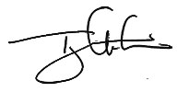
Timothy Lewis
President, Signal-Tech

4985 Pittsburgh Ave., Erie, PA 16509 | Signal-Tech.com

